**Assignment - Improving Operations with Analytics and Data Visualization**

Shaun Pritchard

Rasmussen College

QMB4900

James Grooms

January 16, 2021

**Improving Operations with Analytics and Data Visualization**

Company I would like to discuss who has made it analytics and data visualization in order to improve its operations is Netflix. Netflix is an audiovisual, on demand, distribution or (VOD) company *(Fernández-Manzano, 2016)*. Netflix is one of the biggest data-centric companies on the planet. They use many different models, techniques, and approaches to lead thier innovation through daily data analytics and visualization practices. Using analytics with AI, Machine Learning, and Big data they produce analytics to drive business performance and user engagement. With this data, Netflix can create a detailed profile of its users. Harnessing it into meaningful business information. According to Netflix, they have earned over a billion dollars in customer retention because the recommendation system accounts for over 80% of the content streamed on the platform *(Smith, 2016).*

**Results of Netflix Data Analytics:**

* Netflix has more than 150 Million active subscribers across the planet.
* Data is at the core of Netflix's business strategies and models.
* Netflix video streaming consumes 37% of downstream bandwidth across the entire internet on the planet.

**Netflix Big Data**

Netflix collects customer interaction, engagements, and response data in correlation to data features it collects from users on each TV shows and movie that it streams. They use data analytics to analyze to better understand users based on *(Netflix Research, 2020)*:

* What each customer watches
* How much time they spend watching
* What content they watch
* Location of users
* What times content is watched
* How many times the content is paused
* Which content is fast forward
* Which content is repeated

Their techniques and best practices have become industry standards. They facilitate strategic business approach in which objectives are set; this will establish their parameters and performance indicators (KPI’s) that allow them to Understand how the actually implement data analytics and visualizations which have given them this extraordinary leap in our modern economy. It is best to understand thier real-time data infrastructure to have proper perspective of how analytics and visualization have been used to improve their operations *(OpenLearn, 2020).*

**Netflix infrastructure**

Netflix has a real-time data infrastructure based on in-house technologies that have developed themselves and incorporated custom technologies into platforms such as HADOOP, Python AWS, HIVE, PIG, HBASE, Cassandra, Presto, Spark, S3, Kafka, Amazon web services, and Genie as shown below in there data process flowchart *(Netflix Research, 2020).*

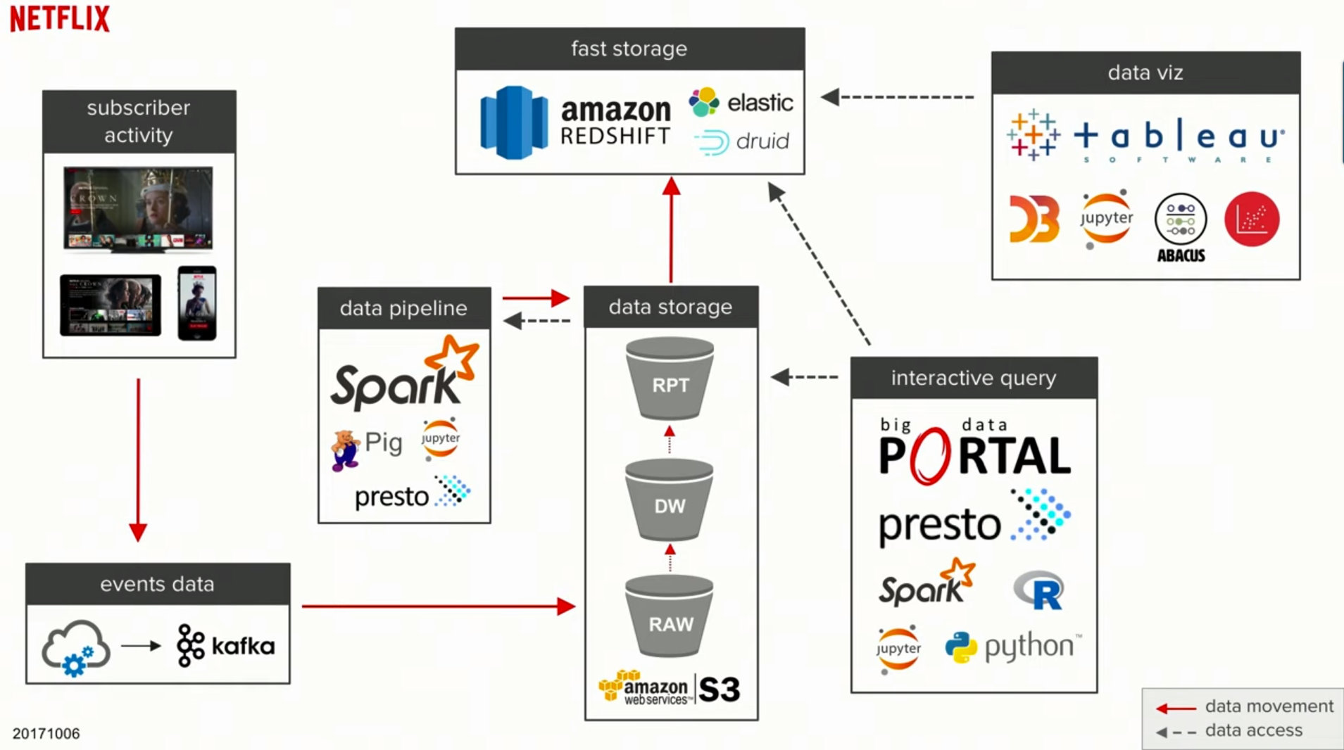

**Departments that Consume Data Analytics:**

Netflix has several areas in which employs its operations to process and analyze data utilizing roles that analyze business data and consumer insights .

1. Analytics
2. Content studio
3. Experimentation R&D
4. Machine learning
5. Personalization search
6. User recommendations.

Each of these departments has access to pull and sample data that it can use for their day to day operation to produce results and make business decisions for their platform. After user data is gathered, put into the data Pipeline, and stored. Netflix provides 2 data access points for their in-house and open source analytics teams and data scientist to utilize. They use data through custom built platforms or third-party tools and APIs. To derive data and analyze it appropriately generating business intelligence for each department according to their needs. Their data access points are as follows:

**Netflix Data Access Points:**

* **Data Visualization** - data analytics platform shared across the whole company for daily operations and analysis.
* **Interactive Query** – an inhouse framework and platform called Presto that allows Netflix to query real time big data and transactions at the same time with thier 10 petabyte data warehouse on Amazon S3.

By collecting data from their 151 million subscribers and implementing data analytics models to discover customer behavior and buying patterns. Then, using that information to recommend movies and TV shows based on their subscribers' preferences. Netflix is the leader in VOD industry and continues to retain and renew its subscribers more than other platforms such as Hulu *(Selerity, 2020).*

Netflix  focuses on innovating and maintaining the analytics metrics to understand performance of the shows, films , users, and other service. From content marketing to strategic business teams that provide business intelligence through useful metrics, insights, predictions, and analytic tools Netflix is a prime example of a company who has reached success through the implementation of data analytics and visualizations. Below is an image of the current business verticals Netflix facilitating through data science and analytics every day.

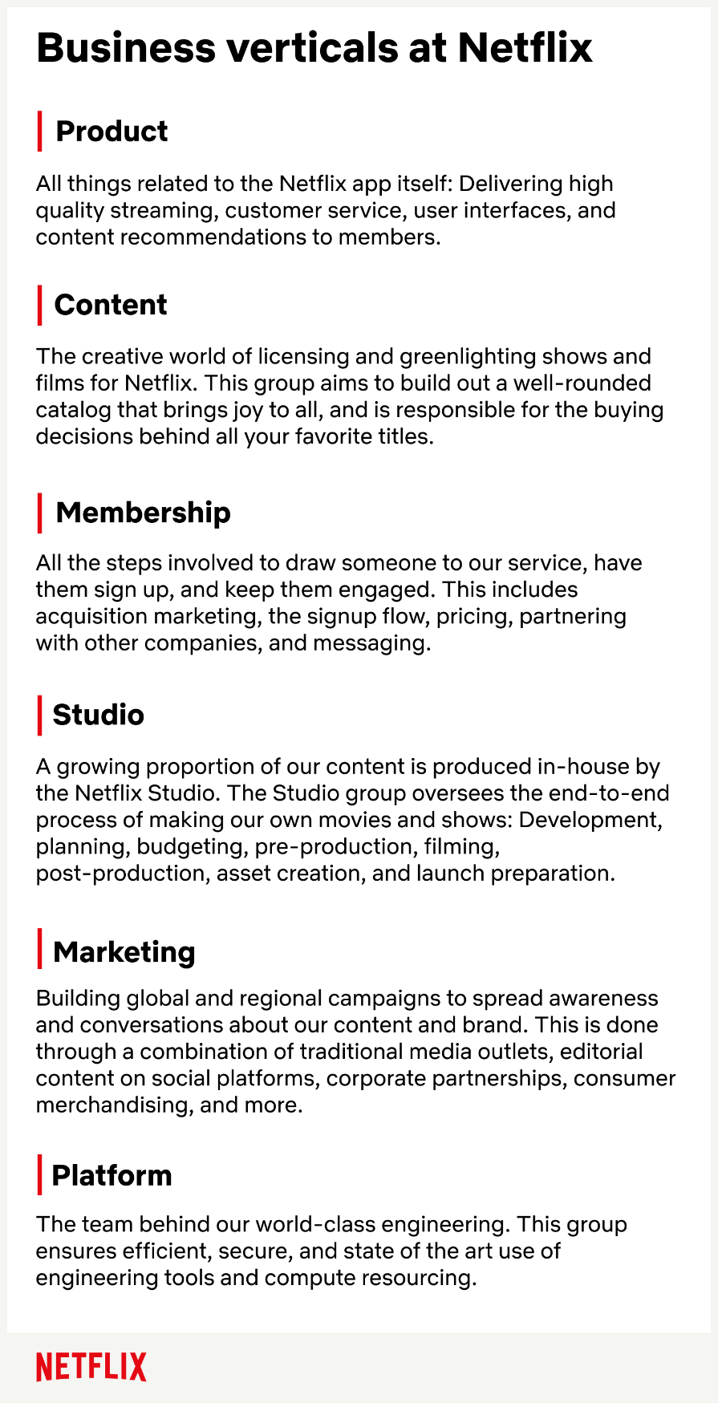

# References

Fernández-Manzano, E.-P. (2016). DATA MANAGEMENT IN AUDIOVISUAL. *El Profesional de la Información*, 1-10.

Netflix Research. (2020). *Netflix Research.* Retrieved from https://research.netflix.com: https://research.netflix.com/articles?q=Analytics

OpenLearn. (2020). *Typical business organisation departments and functions*. Retrieved from https://www.open.edu: https://www.open.edu/openlearn/money-business/organisations-and-management-accounting/content-section-4.1

Selerity. (2020). *How Netflix used big data and analytics to generate billions*. Retrieved from https://seleritysas.com: https://seleritysas.com/blog/2019/04/05/how-netflix-used-big-data-and-analytics-to-generate-billions

Smith, M. D. (2016). *Streaming, Sharing, Stealing : Big Data and the Future of Entertainment.* Massachusetts: The MIT Press.